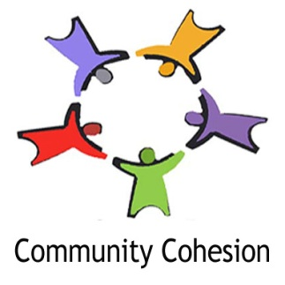

# 6 vanHoogstraaten street, Hout Bay

NPO Number: 104-586-NPO

NPC registration number: 2011/134573/08

5 May 2015

To whom it may concern

Re: Daphne Olivier

I have had the pleasure of working with Daphne for the last couple of months, on a structured level, since she was part of a group I trained to be Volunteer Victim Support Counsellors at the Hout Bay SAPS Victim Support Centre. Prior to that, I was very aware of the services Daphne was providing at Sentinel Primary School, in Hangberg, Hout Bay. Her position there was also voluntary, yet she was the go to person for children in need and a good sounding board for parents as well.

Daphne brings a maturity and head-heart approach to psycho-social issues. She is able to draw on her own life experiences yet not be prejudicial due to these experiences. At times I was concerned that she might be triggered or re-traumatised by her own circumstances when dealing with clients in need, however, this has proven to be unfounded. She has focussed on her own healing and understands her boundaries as well as her limitations and is not afraid to ask for help when and if required.

As a DSD stakeholder partner, Community Cohesion is comfortable seeking Daphne’s input on families in need as well as accepting referrals from her for our Social Workers to intervene.

She brings a level headed, unemotional point of view to a diverse group of volunteers, underpinned by her in depth knowledge of the community she lives in and serves.

Should you require any additional information, please do not hesitate to contact me.

Kind regards

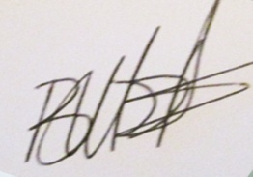

Bronwyn Moore

Director

Community Cohesion

082 9550 546